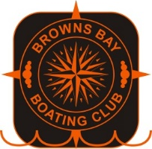
Ahoy all,
Calling all Card Sharks, Gamblers, Poker Faces, Rouletters, and Dice Shysters, take a punt on our “Take a Chance” night Saturday November 7th 2020.
We ran our inaugural fundraising event two years and raised $830 for Hospice North Shore - and last year we nearly doubled that and raised $1,500 for Hospice North Shore.

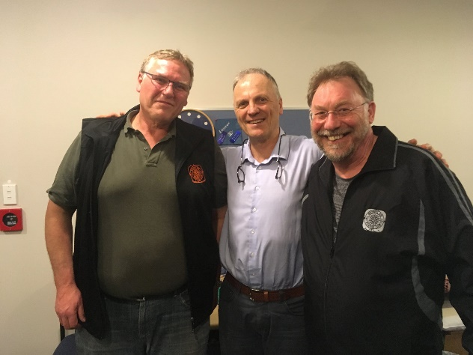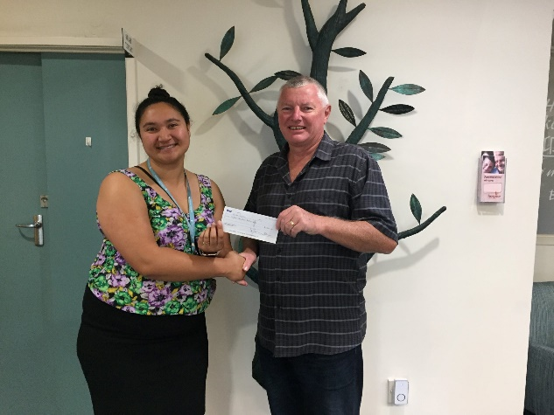
Vaughan Brown from Hospice accepting the cheque Jenna from Hospice and our Commodore Colin Chisholm
two years ago last year

We want to raise the bar again this year and we need your help to reach our target.

Please bring $20 per person to cover the charge to buy your chips. Bar open from 6.30pm, starting at 7pm, Browns Bay Marine Centre. We’ll have snacks available throughout the evening.
Members and Friends welcome, but we do need to ensure aged 18+ to play by the rules. To reserve your chips, please RSVP to Clubcapt@bbbc.co.nz by Wednesday 4th November.

Regards, the Organising Committee

